**WEEK-01**

**Algorithms and Data Structures**

* **Exercise 2: E-commerce Platform Search Function**

**🡺**Solution:

**Code:**

BinarySearch.java

public class BinarySearch {

    public static Product binSearch(Product[] pdts, int id) {

        int s=0;

        int e = pdts.length - 1;

        while (s <= e) {

            int mid = (s + e) / 2;

            if (pdts[mid].productId == id) {

                return pdts[mid];

            } else if (pdts[mid].productId < id) {

                s = mid + 1;

            } else {

                e = mid - 1;

            }

        }

        return null;

    }

}

LinearSearch.java

public class LinearSearch {

    public static Product linSearch(Product[] pdts, int id){

        for (Product pdt : pdts) {

            if (pdt.productId == id) {

                return pdt;

            }

        }

        return null;

    }

}

BubbleSort.java

public class BubbleSort {

    static void sort(Product[] arr) {

        int n = arr.length;

        for (int i = 0; i < n; i++) {

            for (int j = 0; j < n - i - 1; j++) {

                if (arr[j].productId > arr[j + 1].productId) {

                    Product p = (arr[j+1]);

                    arr[j+1] = arr[j];

                    arr[j] = p;

                }

            }

        }

    }

    static void printArr(Product[] arr) {

        for (int i = 0; i < arr.length; i++) {

            System.out.println(arr[i]);

        }

    }

}

Main.java

public class Main {

    public static void main(String[] args) {

        Product[] pdts = {

            new Product(1, "AC", "Appliances"),

            new Product(3, "Cards", "Toys"),

            new Product(2, "Deodrants", "Beauty"),

            new Product(4, "Smart watch", "Gadgets")

        };

        System.out.println("Linear Search: ");

        Product pdt = LinearSearch.linSearch(pdts, 4);

        System.out.println(pdt);

        System.out.println();

        BubbleSort.sort(pdts);

        System.out.println("products list after sorting id:");

        BubbleSort.printArr(pdts);

        System.out.println();

        System.out.println("Binary Search: ");

        Product pdt2 = BinarySearch.binSearch(pdts, 3);

        System.out.println("found pdt: "+ pdt2);

    }

}

**O/P:**

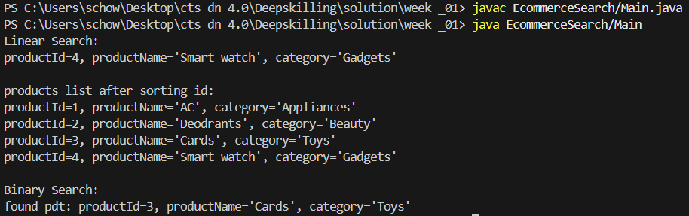

----------------------------------------------------------------------------------------------------------------

* **Exercise 7: Financial Forecasting**

**🡺Solution:**

**Code:**

Finance.java

import java.util.Scanner;

public class Finance {

    public static double calculate(double val, double rate, int year) {

        if (year == 0) {

            return val;

        }

        return calculate((val + val * rate), rate, year - 1);

    }

    public static void main(String[] args) {

        Scanner sc = new Scanner(System.in);

        System.out.print("Enter current value: ");

        float currentVal = sc.nextFloat();

        System.out.print("Enter growth rate: ");

        float rate = sc.nextFloat();

        System.out.print("Enter the number of years: ");

        int year = sc.nextInt();

        double val = calculate(currentVal, rate, year);

        System.out.println(val);

    }

}

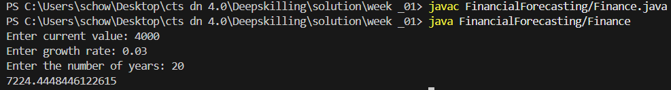**O/P:**